The University of Alabama in Huntsville Space Hardware Club

HELEN Post Mission Report
BalloonSat <##> - <Date>

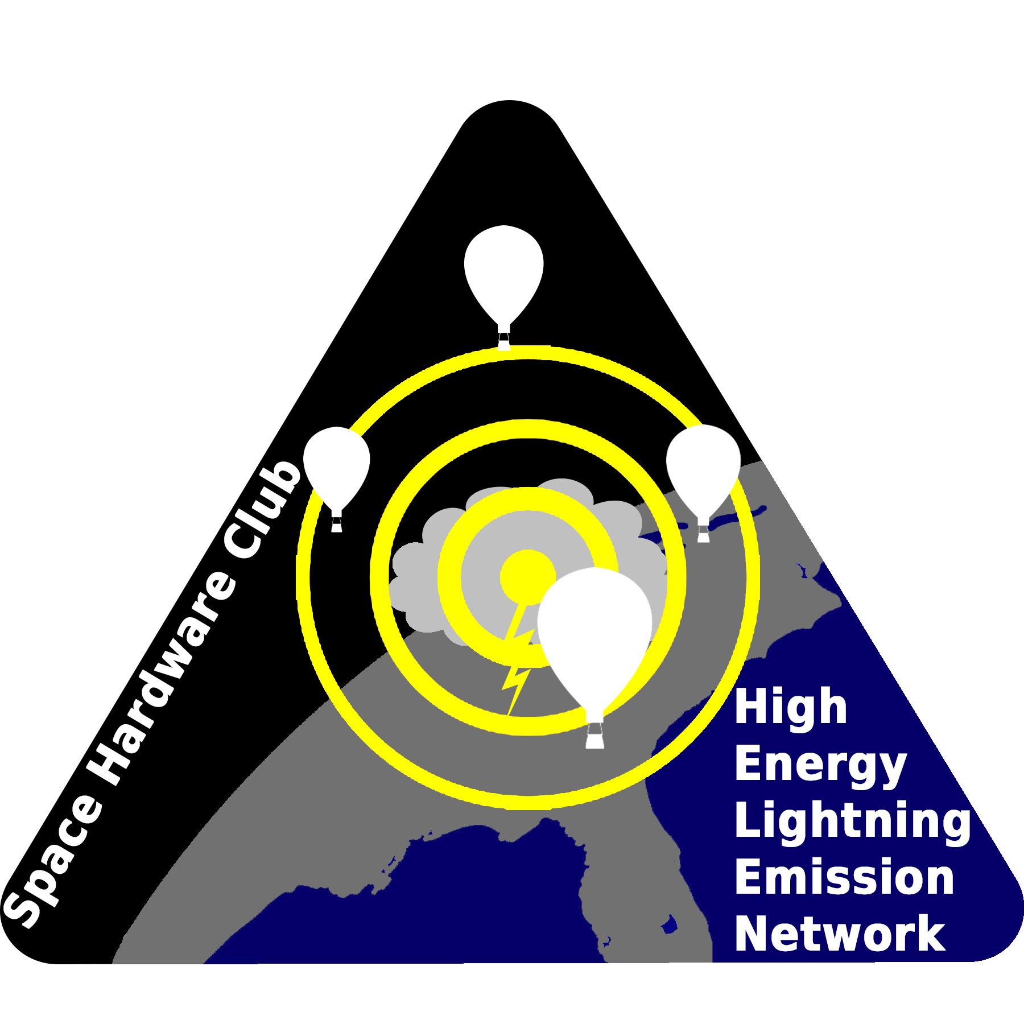

Table of Contents
Table of Contents 2
1 - Flight 3
1.1 - Flight Summary 3
1.2 - Pre-Flight Conditions 3
1.3 - Flight Crew 3
1.4 - Launch Operations Parameters 3
1.5 - Landing and Recovery Efforts 4
1.6 - Launch, Landing, and Recovery Complications 4
2 - Radiation Detection Payload Performance 5
2.1 - Environmental Data Analysis 5
2.1.1 - Overview 5
2.1.2 - Details 5
2.2 - Radiation Data Analysis 6
2.2.1 - Overview 6
2.2.2 - Details 6
2.3 - Significant Events 6
2.4 - Anomaly Analysis 6
3 - Electric Field Meter Flight Performance 6
3.1 - Electric Field Data 6
3.1.1 - Overview 6
3.1.2 - Details 7
3.2 - Significant Events 7
3.3 - Anomaly Analysis 7
4 - Camera Footage 7
2.1 - Camera Footage Summary 7
2.2 - Significant Events 7
5 - Conclusion 7
5.1 - Significant Events 7
5.2 - Lessons Learned 7
5.3 - Mission Summary 7

1 - Flight

1.1 - Flight Summary
BalloonSat <##> was a <test flight / full mission flight / ground test / etc> of <all HELEN payloads / a full balloon train / all Radiation Detection Payloads / etc> performed on <date>. The objective of this mission was to <test / gather scientific measurements / etc> in <environment>. The mission lasted <duration> and recorded <data highlights>. <Describe anomalies / All payloads performed nominally>. Report recovery status.

1.2 - Pre-Flight Conditions
<Timeline>

1.3 - Flight Crew
Table 1: Flight crew names and roles
 | Red | Green | Blue
Flight Lead | <Flight Lead>
Station Leads | <Red Station Lead> | <Green Station Lead> | <Blue Station Lead>
Fill Leads | <Red Fill Lead> | <Green Fill Lead> | <Blue Fill Lead>
Line Leads | <Red Line Lead> | <Green Line Lead> | <Blue Line Lead>
RDP Operators | <Red RDP Operator> | <Green RDP Operator> | <Blue RDP Operator>
EFM Operators | <Red EFM Operator> | <Green EFM Operator> | <Blue EFM Operator>
Balloon Wranglers | <Red Balloon Wranglers> | <Green Balloon Wranglers> | <Blue Balloon Wranglers>


<Team photo if available>

1.4 - Launch Operations Parameters
 | Red | Green | Yellow | Blue
Launch Locations - Name | <Red Station> | <Green Station> |  | <Blue Station>
Launch Locations - Coordinates | <Red Lat>, <Red Long> | <Green Lat>,<Green Long> |  | <Blue Lat>, <Blue Long>
Launch Time | <Red Launch Time> | <Green Launch Time> | <Yellow Launch Time> | <Blue Launch Time>
Landing Time | <Red Landing Time> | <Green Landing Time> | <Yellow Landing Time> | <Blue Landing Time>
Landing Location - Description | <Red Landing Location> | <Green Landing Location> | <Yellow Landing Location> | <Blue Landing Location>
Landing Location - Coordinates | <Red Lat>, <Red Long> | <Green Lat>, <Green Long> | <Yellow Lat>, <Yellow Long> | <Blue Lat>, <Blue Long>
Balloon Neck Lift | <Red Lift> | <Green Lift> | <Yellow Lift> | <Blue Lift>
Train Weight | <Red Weight> | <Green Weight> | <Yellow Weight> | <Blue Weight>
Chute Size | <Red Chute> | <Green Chute> | <Yellow Chute> | <Blue Chute>
Balloon | <Red Balloon> | <Green Balloon> | <Yellow Balloon> | <Blue Balloon>
Tanks of Helium | <Red Tanks of Helium> | <Green Tanks of Helium> | <Yellow Tanks of Helium> | <Blue Tanks of Helium>

1.5 - Landing and Recovery Efforts
Report landing environment and any recovery efforts made or planned. If no efforts made or planned yet, state that.

1.6 - Launch, Landing, and Recovery Complications
Report complications. If none, remove this section.

2 - Radiation Detection Payload Performance

2.1 - Environmental Data Analysis

2.1.1 - Overview

Time Durations
Time on datetime (serial)
Time off datetime (serial)
OPERATION_WINDOWS plot

Maximum altitude
Altitude plot?
GPS_PLOT_COMBINED

Minimum external temperature
Maximum external temperature
External Temperature Plot?

Minimum internal temperature
Mean internal temperature
Maximum internal temperature
Internal temp plot

Number of packets actual
Number of packets expected

2.1.2 - Details
Time GPS on datetime (serial)
Time GPS off datetime (serial)
Packet number first
Packet number last
Packet number gps on
Packet number gps off
Number of packets gps duration
Number of packets per second

Acceleration max x
Acceleration max y
Acceleration max z
Acceleration total plot
Acceleration vertical plot
Acceleration horizontal plot

2.2 - Radiation Data Analysis

2.2.1 - Overview
Number of suspected TGFs
Time duration FPGA (counter resets)
Counts per second mean 1500
Counts per second max 1500
Spectrum channel b 1500 plot
Counts per second 1500 plot
Deadtime mean percent

2.2.2 - Details
Counts total
Counts total 1500
Counts per second mean
Counts per second max
Spectrum Channel A plot
Spectrum Channel B plot
Counts per second plot

2.3 - Significant Events

2.4 - Anomaly Analysis

3 - Electric Field Meter Flight Performance

3.1 - Electric Field Data

3.1.1 - Overview

3.1.2 - Details

3.2 - Significant Events

3.3 - Anomaly Analysis

4 - Camera Footage

2.1 - Camera Footage Summary
Duration
Number of detected events
How’d the payload train look?

2.2 - Significant Events
List of every lightning detection time & detection value (% screen white or whatever)

5 - Conclusion

5.1 - Significant Events

5.2 - Lessons Learned

5.3 - Mission Summary
Click or tap here to enter text.

